EXHIBITION BOOTH GUIDELINE

Basic booth set
Item | Amount | Size (m)
Tent  Exhibition Board  Table (with cloth)  Chair | 1  2  2  5 | W3.6/D2.7/H1.9  0.9 x 1.8  W1.8/D0.6/H0.78
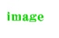
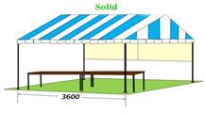
3.6

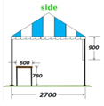
0.9
0.6
0.78
2.7
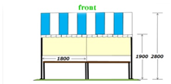
1.8
1.9
2.8

One tent, two Exhibitin Board (peg boards), two tables and five chairs can be used free of charge.
If you need extra items, they will be charged as shown in the table below.
Please let us know the items with quantity, if needed.

Extra optional items:
Item | Charge (2 days per unit)
Tent | JPY 5,000
Exhibition Board | JPY 2,700
Table (with cloth) | JPY 1,300
Chair | JPY 300
Power Generator (20A) | JPY12,000
Power Generator (30A) | JPY14,000

※NOTICE
No permanent power source is available at the booth.
PLEASE apply for a silent type of power generator for a charge if you need a power supply.

